Claude Monet
Name
Institution
Date

Claude Monet
Claude Monet was a known famous French painter who was the principal founder of the French Impressionist painting and was considered to have consistency and as a prolific painter whose main philosophy involved expressing perceptions before and within nature especially on an applied air landscape painting (Bergeret-Gourbin et al, 2014). Claude Monet was born in France in November 14, 1840. His father worked in a shipping work while his mother cared about the whole family. His mother loved poetry and was a famous hostess. At the age of five years, Claude Monet's family relocated to Le Havre in the Normandy Region, where he grew up with his brother. In his school, Monet was not interested in being in the classroom but would instead fill his books with sketches of people (Bergeret-Gourbin et al, 2014). His mother became supportive of his artistic efforts while his father recommended him to get involved in the business.
In 1859, Claude Monet decided to relocate to Paris to follow his passion of pursuing art. He was highly influenced by paintings found in Barbizon school and got enrolled as Academie Suisse’s student (Bergeret-Gourbin et al, 2014). After getting registered as a student, he met a fellow artist called Camille Pissarro, who later became his close and best friend. Eventually, Monet and Camille got married. After serving in the military, he was later discharged from the military due to health issues. He then moved back to Paris, where he ended up studying with Charles Gleyre. Monet ended meeting with famous artists, for example, Auguste Renoir and Alfred Sisley, who gave him great advice and support about landscape painting and the importance of being an influential young artist. Monet loved working outdoors and was usually accompanied by Auguste Reinor and Alfred Sisley on painting sojourns (Berrong, 2017). Most of the time, he would end up getting frustrations about his work, thus destroying some of his paintings by burning, cutting, or kicking the offending art piece. This led him to suffer self-doubt and depression, thus attempting suicide several times.
Claude Monet’s contributions to the art world involved an art movement of impressionism that became concerned with the capture of light and natural light forms. His art movement of impressionism proved to be revolutionary (Berrong, 2017). His inspiring talent was vital to bringing his adherents altogether. His interest was creating paintings in the open air and getting to capture the natural light. In the art world, he brought about the style to one of his popular pinnacles with the famous artistic paintings whereby he observed the similar subjects seen at different moments of the day and got them in several sequences (Berrong, 2017). In the world of art, he was a master of color and light painter and also the atmosphere. Monet’s work hugely achieved a high level of abstraction, thus getting recommendations to different famous painters.
Monet highly contributed to many paintings towards the art world by exploring how human eyes saw landscape or even outdoor scenes. He aimed at capturing real events and watching how they related to the light (Berrong, 2017). In Gare St. Lazare, he showed that a Paris train station could be the middle natural light that shone through the glass roof on a mainly sunny day. He contributed to the world art by painting "a typically middle-class vision of happiness" that were kept with their bourgeois backgrounds. He gave birth to impressionism due to the need for freedom, life zest, and the search for the transformation of painting from its viewpoint to its meaning (Berrong, 2017). He created impressionism to ensure painters moved ahead quickly, thus testing out intense and urgent sensations to prove the essential part of light paintings.
Monet's painting style involved the use of oil paint, pastels, and sketchbooks. He also used a limited variety of colors, banishing browns and earth colours in paintings. His painting style was that of a broken colour that aimed at achieving light sensation in arts (Gedo, 2010). Monet considered that his style of painting an image was characterized by light and color that was created by that image. The core significance of his painting style was how the sun and the moon could clad up different objects in differentiated forms of light. The love for light by Monet was depicted in his works. “For example as explained by Gedo (Gedo, 2010), in Monet’s painting, "The Woman in the Garden," his passion for natural light is recognized when the paintings show the less bright dark tones of the Green dress and natural summer sunlight of the Garden prove to be a perfect display of Monet’s pallet range. The dark blacks and browns of her fur coat seem as endless and as the darkened background behind her while the low lighting illuminates the lighter colors that she clads in. the green in her dress is portrayed, and her skin radiates color against the quiet lit room. The beautiful lit day makes the white dress of his model and freshly cut green grasses are seen as radiant” (Gedo, 2010). Monet’s style of using dark-colored shades of black accentuated his paint. Monet’s use of color is linked to the use of light. His style involved illustrating colors in different ways and by the influence of how objects appeared during the daytime. His usage of dark-colored tones was utilized to further his use of bright colors. Unlike other landscape artists, Monet was favored through the use of light colors as a primary foundation for his painting rather than traditional known dark primers.
The picture below is Claude Monet’s painting "The Woman in the Garden,"
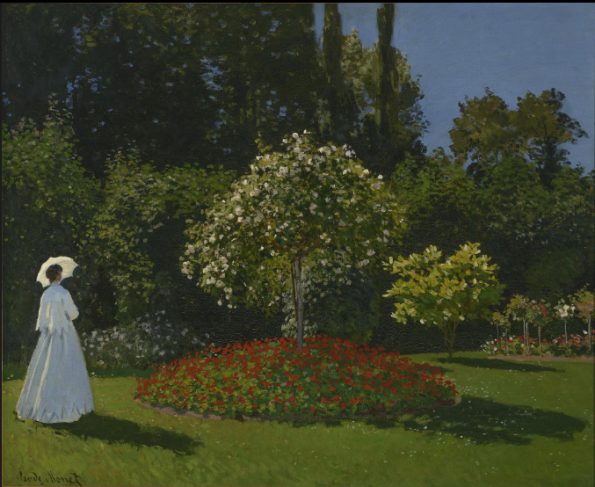
Monet created his best and famous paintings during the 19th century. In early 1880, Monet ended up painting a lot of landscapes and seascapes, whereby he thought them as campaigns that documented his French countryside (King, 2016). In his first years, he painted famous paintings such as Camille and the woman in the garden. In his middle years, he painted "Impression Sunrise," Lilly Pond, and the water lilies. His art was created in the era in which impressionism was founded, thus creating a pathway for a radical art movement. During this era, impressionists such as Monet rebelled against the classicism subject matter (King, 2016). They ended up embracing modernity, thus having the desire towards creating works that created the reflection of the world in which they lived. In this era, impressionists, like Monet, emphasized practicing air painting.
In conclusion, the use of color by Monet towards the end of his career is said to have changed entirely due to his poor health. His paintings are proof that he was a talented artist who left his mark on the world (Thomas, 2010). He seemed to have influenced most forms of art and artists. He contributed a lot in the formation of movements, for example, Impressionism, Pointillism, Symbolism, and Fauvism. He influenced famous artists, for example, Vincent van Gogh and Edgar Degas. Monet contributed to the emergence of Impressionism, and throughout his life, he used his talent to portray the beauty of nature on canvas (Thomas, 2010). Monet may have died almost a century ago; however, his beautiful art will live on forever.

References
Bergeret-Gourbin, A. M., Chatellier, C., Lefebvre, G., Manoeuvre, L., & Olson, D. W. (2014). Monet's Impression Sunrise: The Biography of a Painting. Hazan.
Berrong, R. M. (2017). Putting Monet and Rembrandt into Words: Pierre Loti's Recreation and Theorization of Claude Monet's Impressionism and Rembrandt's Landscapes in Literature. The University of North Carolina Press.
Gedo, M. M. (2010). Monet and His Muse: Camille Monet in the Artist's Life. University of Chicago Press.
King, R. (2016). Mad Enchantment: Claude Monet and the Painting of the Water Lilies. Bond Street Books.
Thomas, G. M. (2010). Impressionist children: childhood, family, and modern identity in French art (pp. 167-74). New Haven: Yale University Press.

